Project Design Phase-II
Data Flow Diagram & User Stories
Date | 31 January 2025
Team ID | ________________
Project Name | Automated Network Request Management in ServiceNow
Maximum Marks | 4 Marks

Data Flow Diagrams:
A Data Flow Diagram (DFD) is a traditional visual representation of the information flows within a system. It shows how data enters and leaves the system, how information is processed, and where data is stored. The following Level-0 DFD represents the proposed Automated Network Request Management system in ServiceNow.
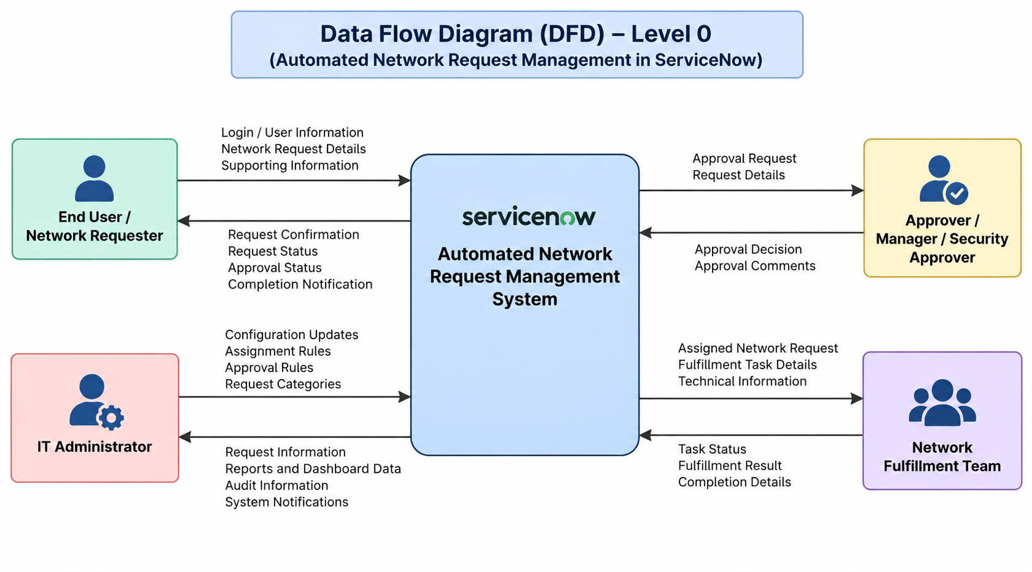
Figure 1: Data Flow Diagram (DFD) – Level 0
Level-0 Data Flow Description
End User / Network Requester: Submits user information, network request details and supporting information; receives confirmation, status, approval and completion notifications.
Approver: Receives approval requests and request details; sends approval decisions and comments.
Network Fulfillment Team: Receives assigned requests and task details; updates task status and fulfillment results.
IT Administrator: Maintains request categories, assignment and approval rules; receives reports, dashboard and audit information.

User Stories
The following user stories translate the functional requirements of the proposed system into actionable user-focused requirements.
User Type | Functional Requirement (Epic) | User Story Number | User Story / Task | Acceptance Criteria | Priority | Release
End User / Requester | Network Request Submission | USN-1 | As a requester, I can access the Network Request Catalog so that I can select the required network service. | Request categories are visible and a request type can be selected. | High | Sprint-1
End User / Requester | Network Request Submission | USN-2 | As a requester, I can submit a network request by entering the required request information. | Mandatory information can be entered and the request submitted. | High | Sprint-1
End User / Requester | Request Form & Validation | USN-3 | As a requester, I can see mandatory fields and validation messages so that I can provide complete request information. | Required fields are identified and incomplete requests cannot be submitted. | High | Sprint-1
End User / Requester | Request Tracking & Notifications | USN-4 | As a requester, I can view the current status of my network request. | Relevant lifecycle status is visible. | High | Sprint-1
End User / Requester | Request Tracking & Notifications | USN-5 | As a requester, I can receive notifications when my request status changes. | Relevant submission, approval, fulfillment and closure notifications are generated. | Medium | Sprint-2
Approver | Approval Management | USN-6 | As an approver, I can view network requests that require my approval. | Pending approval requests are visible to the authorized approver. | High | Sprint-1
Approver | Approval Management | USN-7 | As an approver, I can approve or reject a network request. | The approver can approve or reject and provide comments when required. | High | Sprint-1
Approver | Approval Management | USN-8 | As an approver, I can receive notifications for requests requiring my approval. | The approver receives relevant approval notifications. | Medium | Sprint-2
Network Fulfillment Team | Automated Assignment & Fulfillment | USN-9 | As a network team member, I can view network requests assigned to my fulfillment group. | Assigned requests are available to authorized team members. | High | Sprint-1
Network Fulfillment Team | Automated Assignment & Fulfillment | USN-10 | As a network team member, I can view the technical details required to fulfill a network request. | Relevant request information is available from the task. | High | Sprint-1
Network Fulfillment Team | Automated Assignment & Fulfillment | USN-11 | As a network team member, I can update the status of a fulfillment task. | Task status and details can be updated. | High | Sprint-2
Network Fulfillment Team | Automated Assignment & Fulfillment | USN-12 | As a network team member, I can record the completion details of a network request. | Completion information is saved and the request can proceed to closure. | Medium | Sprint-2
IT Administrator | Request Management & Administration | USN-13 | As an IT administrator, I can manage network request categories and catalog items. | Authorized administrators can configure request types. | High | Sprint-1
IT Administrator | Request Management & Administration | USN-14 | As an IT administrator, I can configure approval and assignment rules. | Authorized administrators can define approvers and fulfillment groups. | High | Sprint-2
IT Administrator | Audit & Reporting | USN-15 | As an IT administrator, I can monitor network requests using reports or dashboards. | The administrator can view request status and fulfillment activity. | Medium | Sprint-2
IT Administrator | Audit & Reporting | USN-16 | As an IT administrator, I can view request history and audit information. | Authorized administrators can review request, approval and fulfillment history. | Medium | Sprint-2

User Story to Functional Requirement Mapping
Functional Requirement | Related User Stories
FR-1 Network Request Submission | USN-1, USN-2
FR-2 Request Form & Validation | USN-3
FR-3 Approval Management | USN-6, USN-7, USN-8
FR-4 Automated Assignment & Fulfillment | USN-9, USN-10, USN-11, USN-12
FR-5 Request Tracking & Notifications | USN-4, USN-5
FR-6 Request Management & Administration | USN-13, USN-14
FR-7 Audit & Reporting | USN-15, USN-16

